**Lesson 2 Practice Hands-On**

**Directions**

For your Lesson 2 Practice Hands-On, you will be practicing your new knowledge on objects and will be working within Visual Studio Code. This Hands-On will not be graded, but we encourage you to complete it. The best way to become a great programmer is to practice! Once you have submitted your project, you will be able to access the solution on the next page.

**Setup**

1. Open up your terminal/command prompt.
2. Navigate to your desktop in your terminal.
3. cd Desktop
4. Next, navigate to the FullStackWeb directory in your terminal.
5. cd FullStackWeb
6. Then, navigate to the FrontEndFoundations directory in your terminal.
7. cd FrontEndFoundations
8. Create a new project folder named L02HandsOn located within the FrontEndFoundations folder in your terminal.
9. mkdir L02HandsOn
10. Once the process is complete, navigate into the L02HandsOn directory:
11. cd L02HandsOn
12. Run the following to open your new project in VS Code (or you can open the folder within VS Code directly):
13. code .
14. Create two new files: index.html and script.js in VSCode by selecting the add file button shown below:

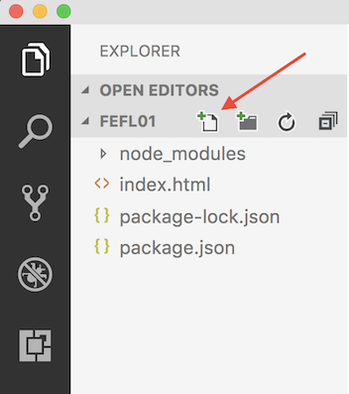

1. Link your JavaScript file to your HTML file using <script src="script.js"></script>

**Requirements**

Complete the following within this project.

**Step 1**

* Within the script.js file, add the following:
  + Create an object named idealCar
  + Within the idealCar object, add the following:
    - a name property with a value of mustang
    - a color property with a value of red
    - a weightInPounds property with a value of 3600
    - a method named myCar that takes each of the values, links them together and console.logs the string My ideal car is a mustang with a color of red, but I do not want it to be over 3600 pounds.
      * You will need to use the this keyword.
* Call the function at the bottom of your file so you can see the console.log running in your console.
* Use the http-server to open your project in the web browser.
  + Right-click on the webpage and click Inspect and then choose console to see your console.log.
  + Remember, if you make changes, you may have to do a **hard reload** of your page because you are using the http-server.

**Example**

